Chapter 1 Exercises
  - Given the waveforms of voltage v and current i of an element as shown in fig. p1-1, and assume they have associated reference direction. Find the waveforms of the waveform of corresponding power p and energy w absorbed by the element.
Solution
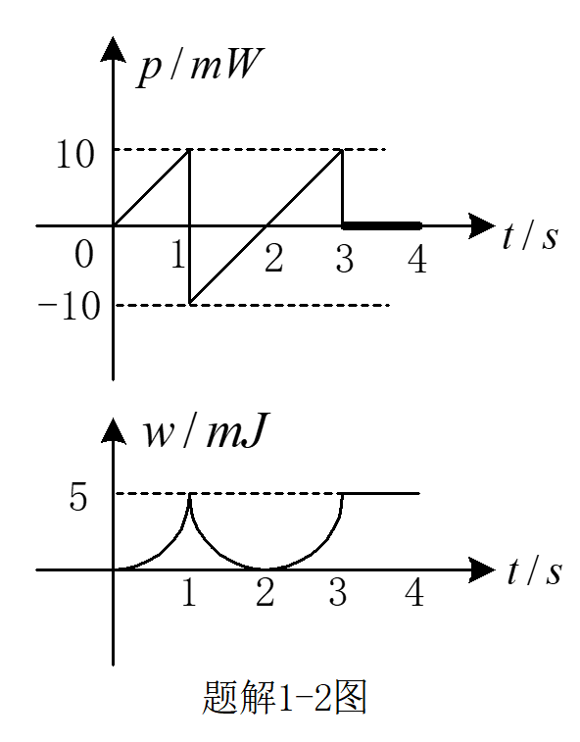
  - For each element in figure P1-2, find
- v_{a} , if element A absorbs a power of 10W.
- i_{b} , if element B dissipates 10W.
- i_{b} , if element C absorbs -10W.
- Power absorbed by element D.
- i_{e} , if element E gives out a power of 10W.
- v_{f} , if element F supplies a power of -10W.
- i_{g} , if element G supplies 10mW.
- Power supplied by element H.
Solution
  - For each element in fig. P1-3, the reference directions of its voltage and current are shown in the figure. Some values of these variables are known as listed in table P1-3. Compute the remaining unknowns shown as question marks.

Table P1-3 Variable values in Fig. P1-3
Variable | Element1 | Element 2 | Element 3 | Element 4 | Element 5
v | +100V | ? | +25V | ? | ?
i | ? | +5mA | ? | ? | ?
p | -1W | ? | ? | 0.75W | ?
Solution
Table P1-3 Variable values in Fig. P1-3
Variable | Element1 | Element 2 | Element 3 | Element 4 | Element 5
v | +100V | 100V | +25V | 75V | -75V
i | -0.01A | +5mA | -5mA | 10mA | -5mA
p | -1W | 0.5W | 125mW | 0.75W | -375mW

  - For the circuit in Fig. P1-4
- Identify all nodes and loops in the circuit.
- Find out all series and parallel combinations of elements.
- Write KCL and KVL equations.
- If and , find other currents.
Solution
- Nodes: a, b, c
Loops: a-c-a, a-c(1)-b-a, a-c(2)-b-a
- 1p2, 3s4, 2p(3s4), 1p(3s4), 1p2p(3s4)
- KCL:
KVL:
  - Variables in a circuit with 5 elements meet the following Kirchhoff law constrains
Assume every pair of voltage and current for an element satisfies passive sign convention, draw the circuit.
Solution
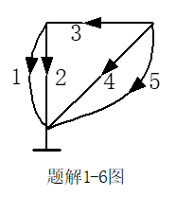
  - Determine the current i_{x} in each graph of Fig. P1-6.
Solution
  - A voltage divider with multiple output voltage selections is shown in fig. P1-7. By using KVL, determine its output voltage for each switching position A,B,C,D,E and E.
Solution
A．
B．
C．
D．
E．

  - Calculate the voltage across current sources and the current through voltage sources as shown in circuits in fig. P1-1.
Solution
(a)
(b)
(c)

  - Find v and i in the circuit of figure P1-9.
Solution
（a）

(b)

  - Find the branch currents i₁, i₂ and i₃ in figure P1-10.
Solution
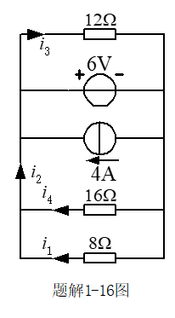

  - Find current i_{x} and voltage v_{x} in in the circuits of figure P1-11.
Solution
(a)
(b)
(c)

  - Use inspection method to determine i, v and the power drawn by element x in figure P1-12.
Solution
Assign the reference directions as shown in Fig. P1-12’.
  - If node A, B and C are connected to ground in the circuit of P1-13, determine the potentials of node D and E, and calculate currents i_{B} and i_{C} .
Solution

  - Find the potentials of node A, B and C for circuits in figure P1-14.
Solution

  - In figure P1-15, the 5-A current source supplies 125W to the rest of the circuit. Find resistance R and conductance G.
Solution
  - The part of circuit shown in figure P1-16 is a voltage divider.
- Find the relation of v₁ to v₂ when i₁ =0.
- Find the relation of v₁ to v₂ when i₂ =0.
- Find the relation of i₁ to i₂ when v₁ =0.
- Find the relation of i₁ to i₂ when v₂ =0.
Solution
(1)
(2)
(3)
（4）
  - In figure P1-17, the resistor pack consists of three resistors, and is used together with an external 12-V voltage source and conducting wires to form a voltage divider giving 6V output v₀. Follow this example to form more dividers to obtain 3V, 4V, 8V and 9V output. Try to change the way the 12V source is connected and the way the pins are wired, and select different nodes to output voltage with respected to ground.
Solution

  - Design a voltmeter with multiple input voltage full scales. In the measuring circuit of figure P1-18, the ammeter allows a maximum current of I₀=50μA and functions like a resistor of . How should the resistances for R1, R2, R3 be designed.
Solution
1V：
10V：
100V：

  - Find v_{ab} in the circuit of P1-19 where both potentiometers have their moving end at the middle position. Use EWB simulation to verify the result.
Solution

  - Find i for the circuits in figure P1-20.
Solution
Redraw circuit(a) as
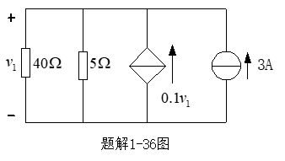
Applying KCL: get
(b) Applying KVL:
Substituteinto the equation above,
get

  - Calculate the power absorbed by each element in figure P1-21.
Solution
  - Find i_{a} in P1-22.
Solution
Redraw circuit P1-22 as

